This is a test. Let’s add a picture.

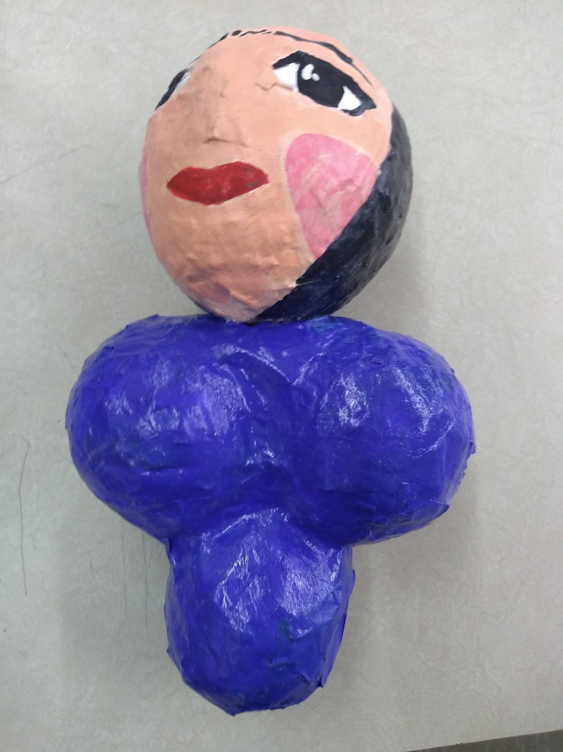

And maybe an Excel sheet.

|  |  |
| --- | --- |
| 1 | 3 |
| 2 | 5 |
| 3 | 7 |
| 4 | 9 |
| 5 | 5 |