Here we can see that the memory is correct: €1 = 1 EUR. But segment 4730 has been translated and locked (by the client) as £1 = 1 EUR

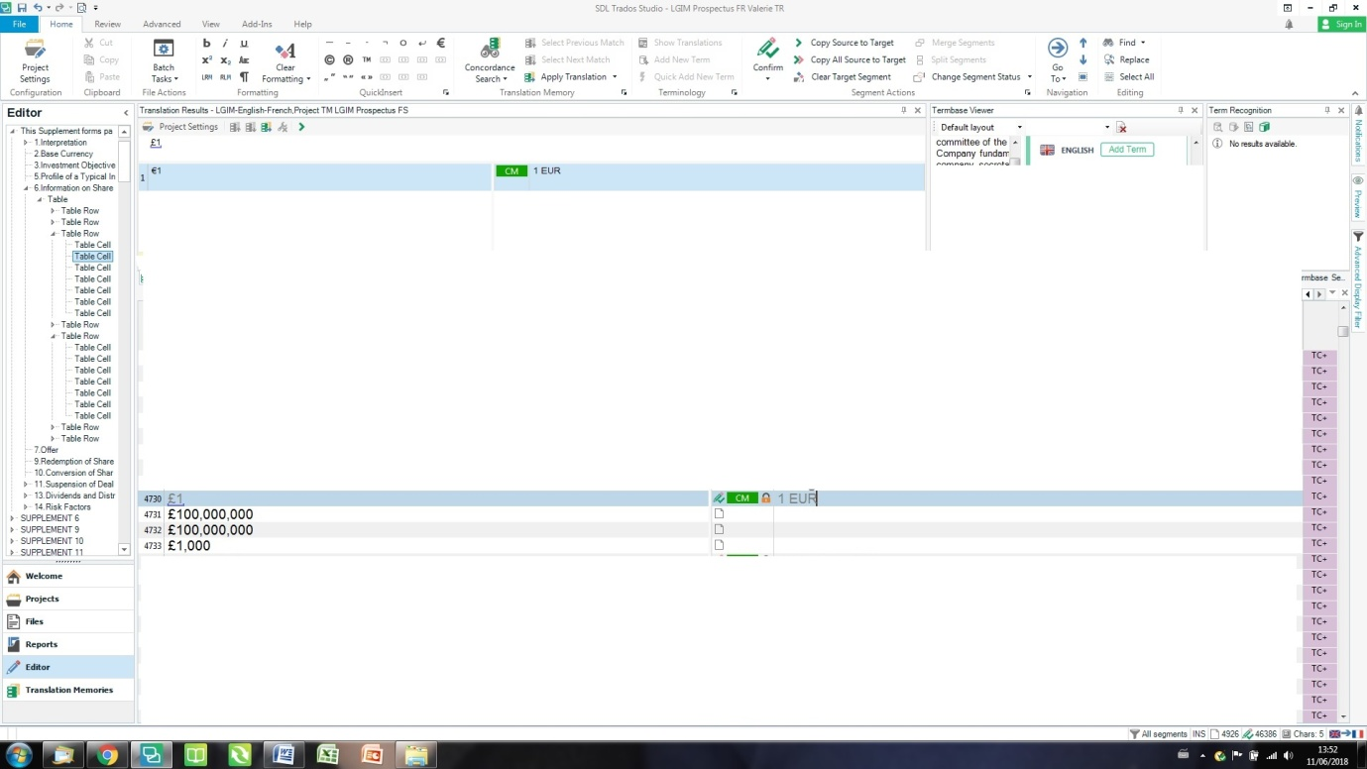

And here at segment 4731, the memory is also correct €100,000,000 = 100 000 000 EUR, but Studio gives me a 100% match £100,000,000 = 100 000 000 EUR

