Content Manager:

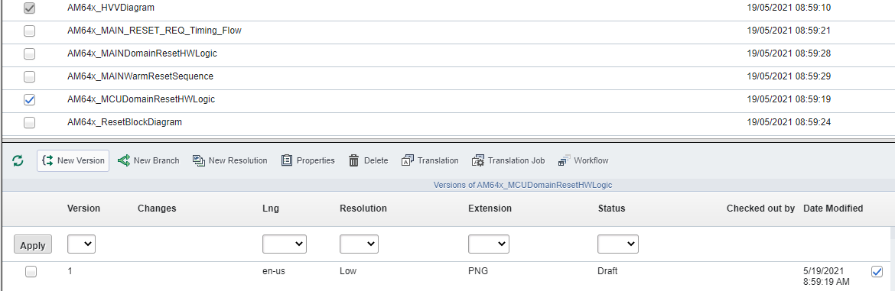

Browse Repository:

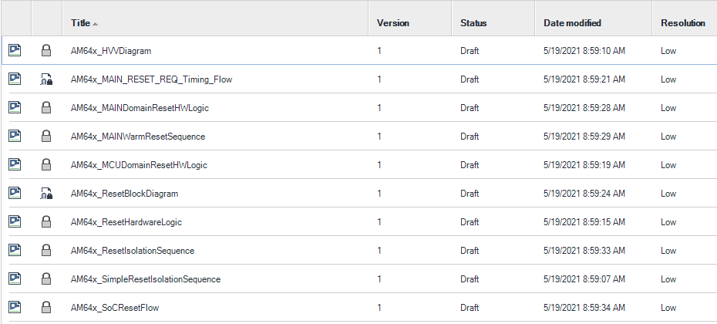

Publication Manager:

|  |  |
| --- | --- |
| Publication | Baseline |
|  |  |