In an attempt to see where I am going wrong, I am submitting this document.
I saved the xml text as a .txt document with the proper UTF 8 encoding.
I followed instructions to create a parser.
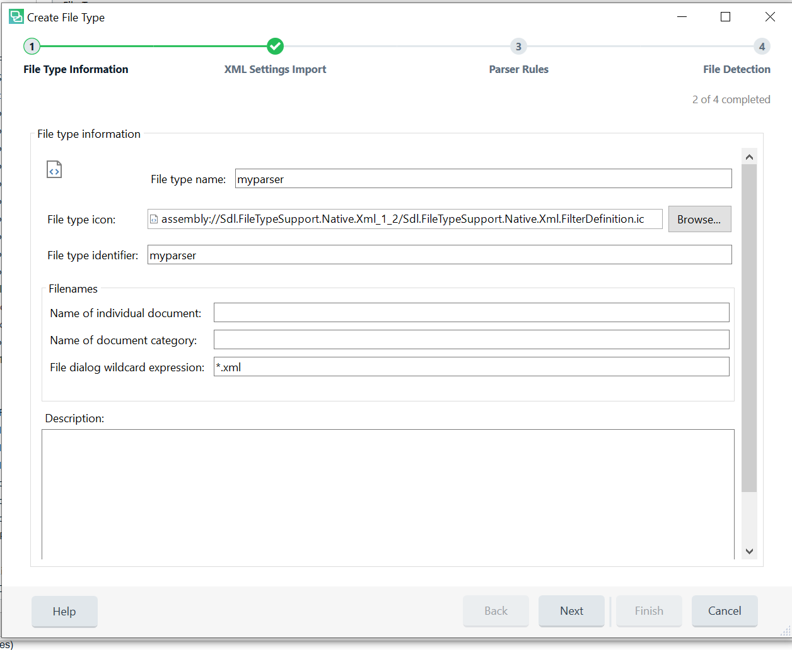

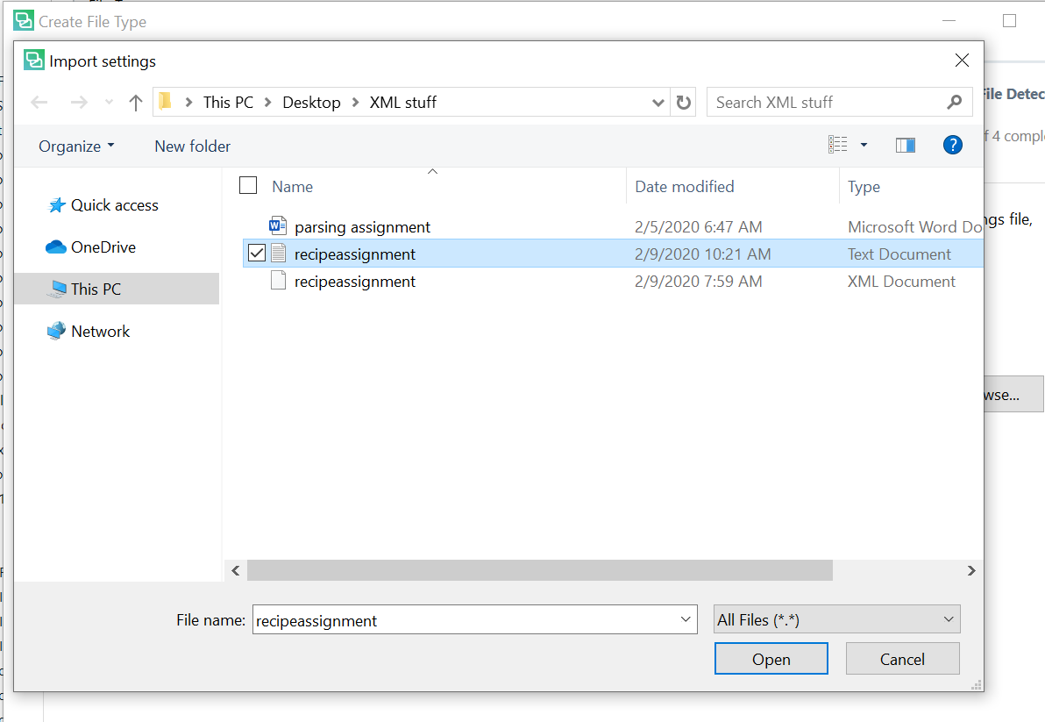

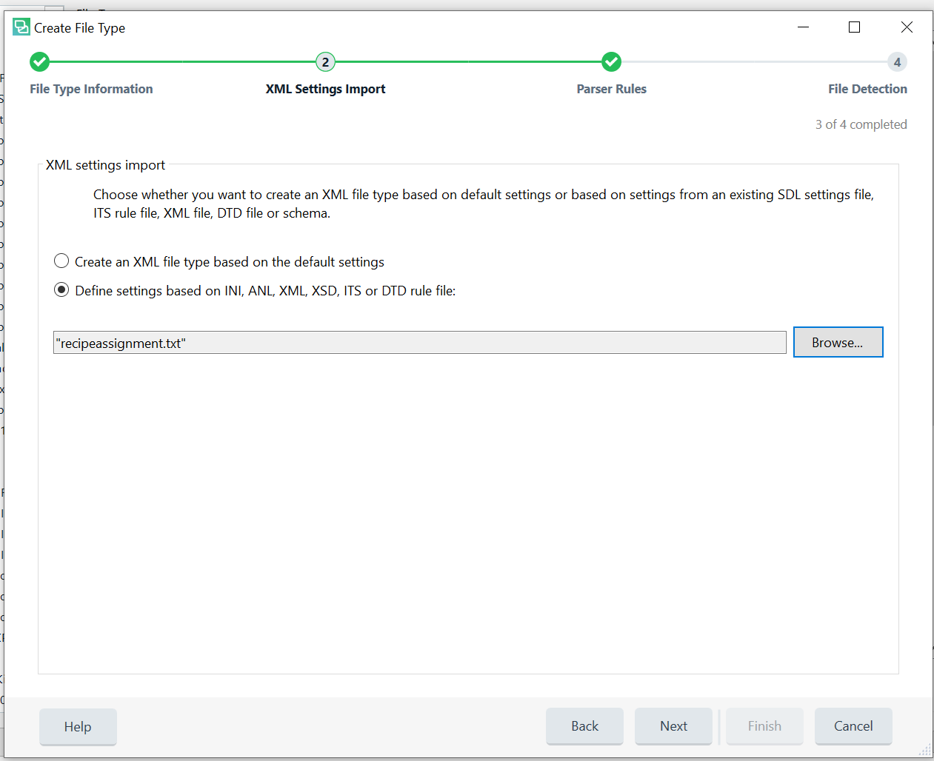
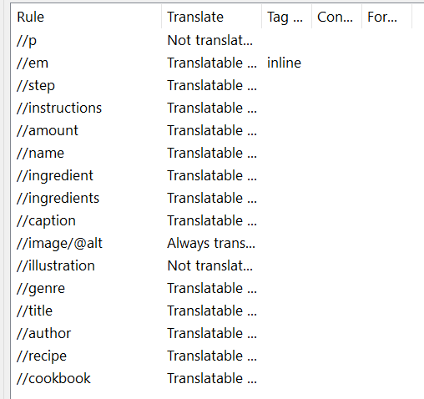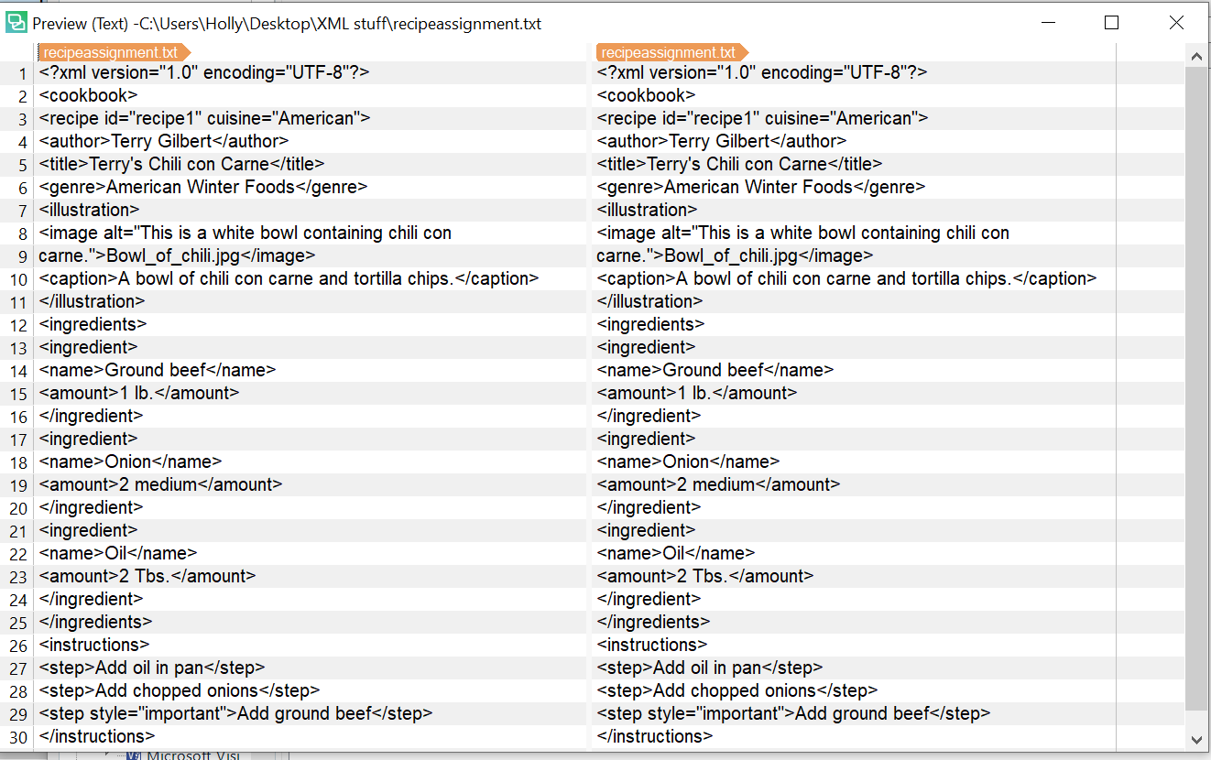
So, then I get these rules and make the changes I think necessary. The first element is structural, so I change it to not translatable. The alt text for the image should always be translatable to be ADA compliant. The caption I left as translatable but could have marked as always translatable. The illustration I marked as not translatable since it was just a jpeg.
When I ran my document through the previewer with my parser, I got this. So, what am I doing wrong? Also, do I need to add rules to the parser to eliminate the XML tags?

