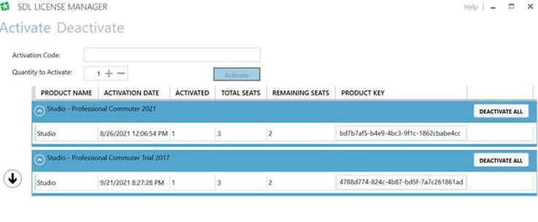Though on the account it says “in use 3” while only one is activated on the server manager:

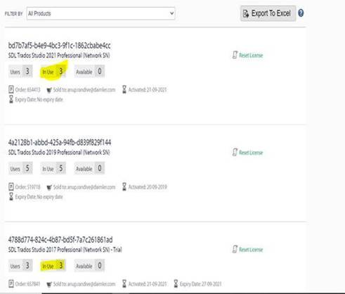

I can see it on the WlmAdmin as well.

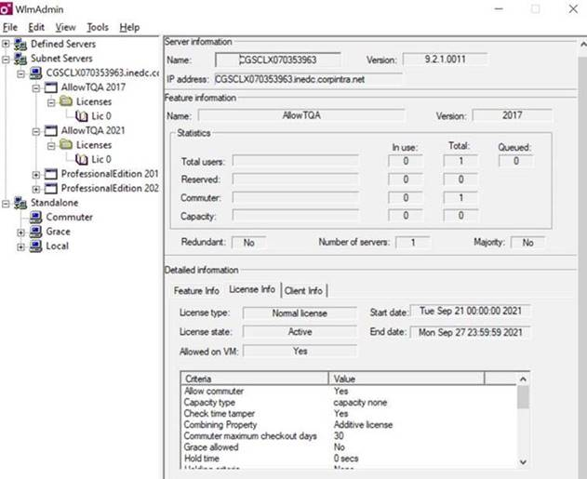

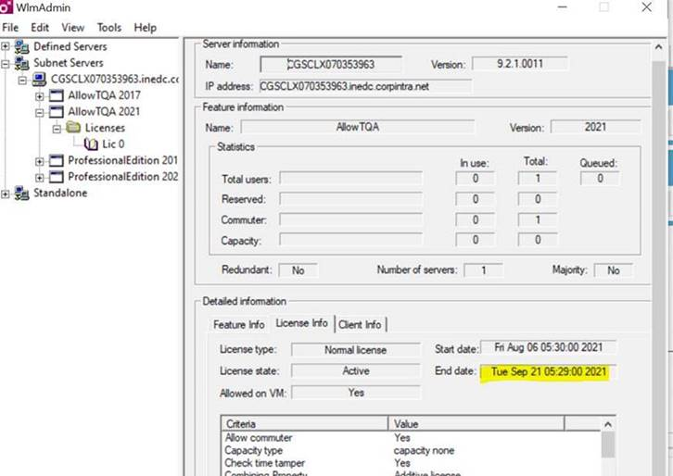

But below is the error I get when I try to activate the trail or the other license via license server

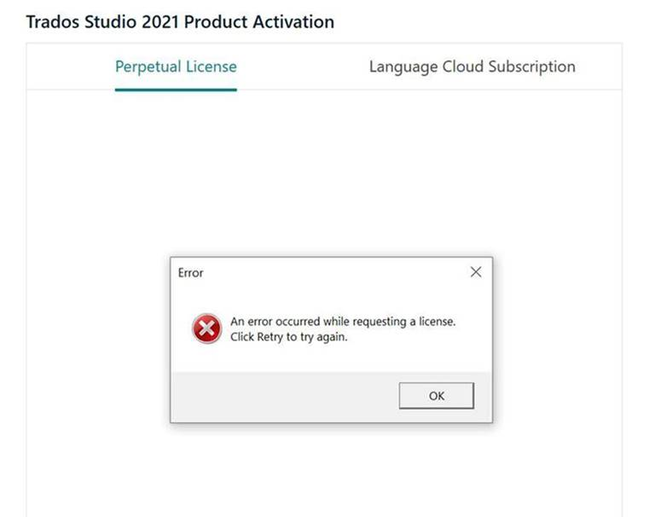

And this is the error when I try to activate with the trail or the other license using activation code directly.

