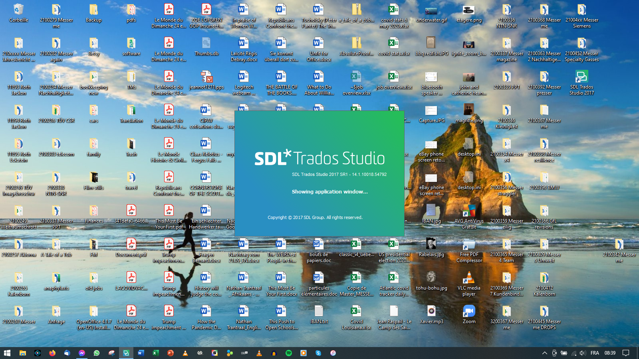

Launch sequence:

* Checking license…
* Executing Setup wizard…
* Executing telemetry (?)…
* [\*\*\* several other status messages, too fast for me to record \*\*\*]
* Initializing views…
* Loading Projects view…
* Showing application window…

--- and then nothing.

Hover cursor over icon in taskbar, miniature app window is blank:

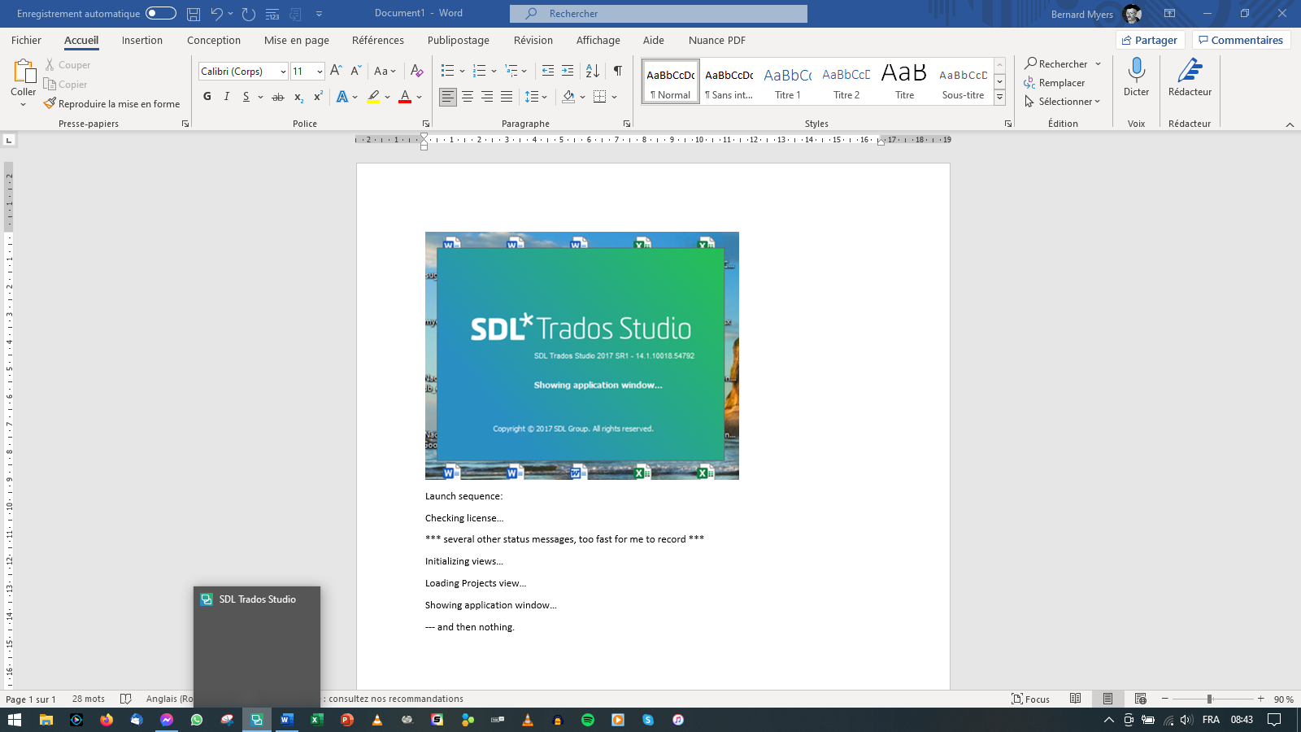

Task Manager says application is running:

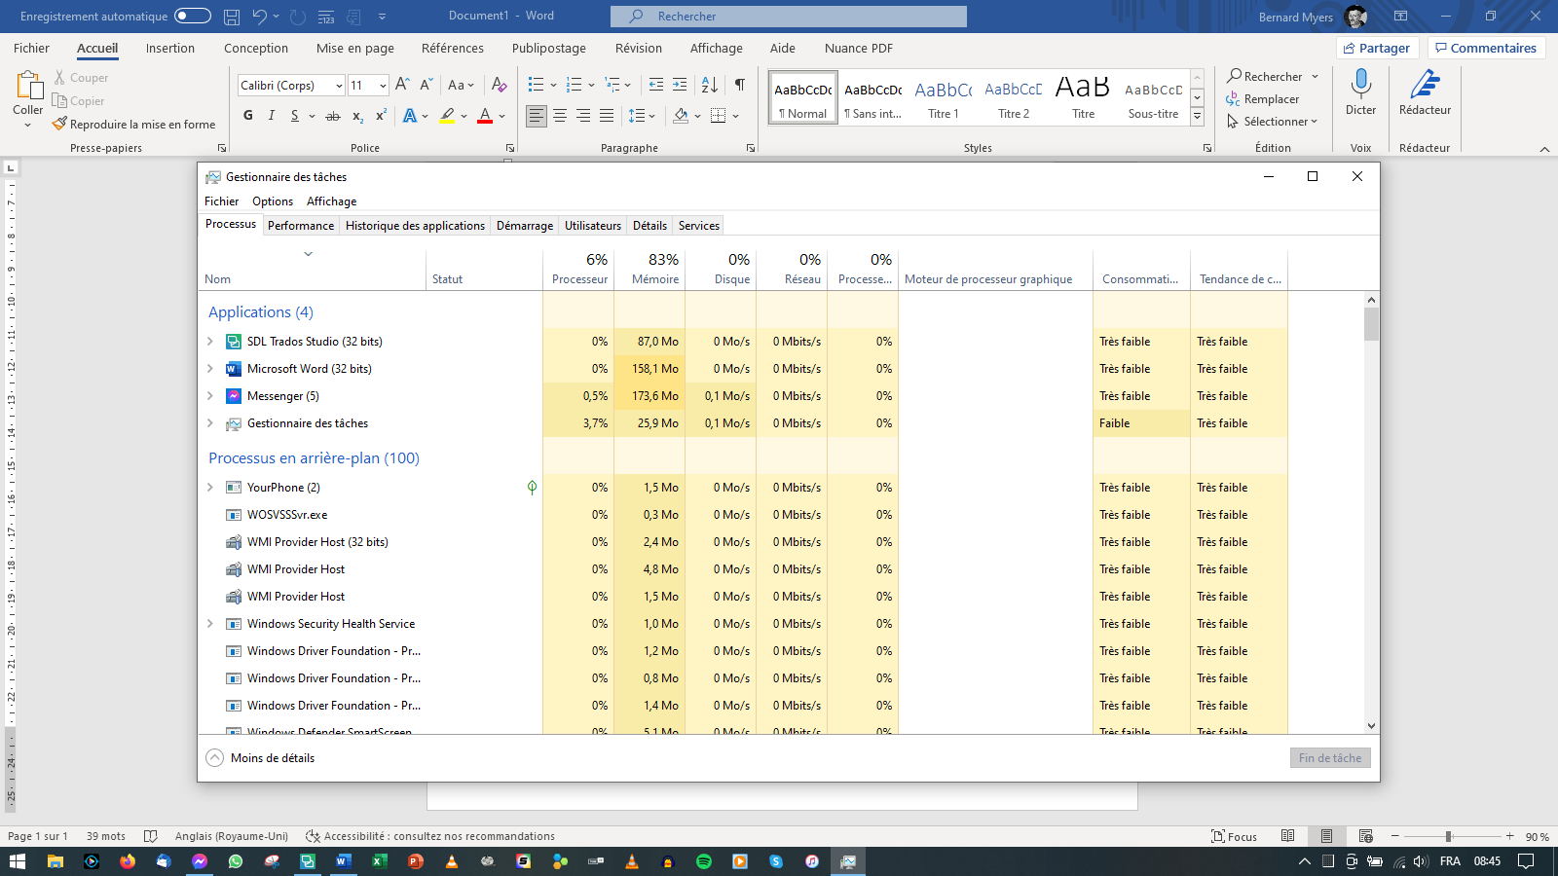

Deleted and reinstalled application (fresh download from SDL), nothing changed.

Problem started right after switching display language from French to English???